**CHAPTER 1**

**COMPANY PROFILE**

**1.1 A BRIEF HISTORY OF VARCONS TECHNOLOGIES PRIVATE**

**LIMITED**

Varcons Technologies, was incorporated with a goal” To provide high quality and optimal Technological Solutions to business requirements of our clients”. Every business is a different and has a unique business model and so are the technological requirements. They understand this and hence the solutions provided to these requirements are different as well. They focus on client’s requirements and provide them with tailor made technological solutions. They also understand that Reach of their Product to its targeted market or the automation of the existing process into e-client and simple process are the key features that our clients desire from Technological Solution they are looking for and these are the features that we focus on while designing the solutions for their clients.

Sarvamoola software services. is a Technology Organization providing solutions for all web design and development, MYSQL, PYTHON Programming, HTML, CSS, ASP.NET and LINQ? Meeting the everincreasing automation requirements, Sarvamoola software services. Specialize in ERP, Connectivity, SEO Services, Conference Management effective web promotion and tailor-made software products, designing solutions best suiting to client’s requirements.

Varcons Technologies, strive to be the front runner in creativity and innovation in software development through their well-researched expertise and establish it as an out of the box software development company in Bangalore, India. As a software development company, they translate this software development expertise into value for their customers through their professional solutions.

They understand that the best desired output can be achieved only by understanding the clients demand better. Varcons Technologies work with their clients and help them to define their exact solution requirement. Sometimes even they wonder that they have completely re defined their solution or new application requirement during the brainstorming session, and here they position themselves as an IT solution consulting group comprising of high calibre consultants.

They believe that Technology when used properly can help any business to scale and achieve new heights of success. It helps Improve its efficiency, profitability, reliability; to put it in one sentence” Technology helps you to Delight your Customers” and that is what we want to ac

**CHAPTER 2**

**ABOUT THE COMPANY**

Varcons Technologies is a Technology Organization providing solutions for all web design and development, MYSQL, PYTHON Programming, HTML, CSS, ASP.NET and LINQ. Meeting the ever-increasing automation requirements,

Varcons Technologies specialized in ERP, Connectivity, SEO Services, Conference Management, effective web promotion and tailor-made software products, designing solutions best suiting client’s requirements. The organization where they have a right mix of professionals as a stakeholder to help us serve our clients with best of our capability and with as per industry standards. They have young, enthusiastic, passionate and creative Professionals to develop technological innovations in the field of Mobile technologies, Web applications as well as Business and Enterprise solution. Motto of our organization is to “Collaborate with our clients to provide them with best Technological solution hence creating Good Present and Better Future for our client which will bring a cascading a positive effect in their business shape as well”. Providing a Complete suite of technical solutions is not just our tag line, it is Our Vision for Our Clients and for u We strive hard to achieve it.

**2.1 PRODUCTS OF VARCONS TECNOLOGIES.**

It is the process by which new applications are created for devices running the

Android operating system. Applications are usually developed in Java (and/or Kotlin; or other such option) programming language using the Android software development kit (SDK), but other development environments are also available, some such as Kotlin support the exact same Android APIs (and bytecode), while others such as Go have restricted API access.

The Android software development kit includes a comprehensive set of development tools. These include a debugger, libraries, a handset emulator based on QEMU, documentation, sample code, and zutorials. Currently supported development platforms include computers running Linux (any modern desktop Linux distribution), Mac OS X 10.5.8 or later, and Windows 7 or later. As of March 2015, the SDK is not

available on Android itself, but software development is possible by using specialized Android

applications.

It is a client–server computer program in which the client (including the user interface and client- side logic) rinsing web browser. Common web applications include webmail, online

retail sales, online auctions, wikis, instant messaging services and many other functions. Web applications use web documents written in a standard format such as HTML and JavaScript, which are supported by a variety of web browsers. Web applications can be considered as a specific variant of client– server software where the client software is downloaded to the client machine when visiting the relevant webpage, using standard procedures such as HTTP. The Client web software updates may happen each time the webpage is visited. During the session, the web browser interprets and displays the pages, and acts as the universal client for any web application. The use of web application frame work scan often reduces the number of errors in a program, both by making the code simpler, and by allowing one team to concentrate on the framework while another focuses on a specified use case. In applications which are exposed to constant hacking attempts on the Internet, security-related problems can be caused by errors in the program.

Frame works can also promote the use of best practices such as GET after POST. There are some who view a web application as a two-tier architecture. This can be a “smart” client that performs all the work and queries “dumb” server, or a “dumb” client that relies on a “smart” server. The client would handle the presentation, these would have the data base (storage tier), and the business logic (application tier) would be on one of the morons both. While this increases the scalability of the applications and separates the display and the database, it still doesn’t allow for true specialization of layers, so most applications will outgrow this model. An emerging strategy for application software companies is to provide web access to software previously distributed as local applications. Depending on the type of application, it may require the development of an entirely different browser-based interface, or merely adapting an existing application outside different presentation technology. These programs allow the user to pay a monthly or yearly fee for use of a software application without having to installation a local hard drive. A company which follows this strategy is known as an application service provider (ASP), and ASPs are currently receiving much attention in the software industry.

Security breaches on these kinds of applications are a major concern because it can involve both enterprise information and private customer data. Protecting these assets is an important part of any web application and there are some key operational areas that must be included in the development process. This includes processes for authentication, authorization, assets handling, input, and logging and auditing. Building security into the applications from the beginning can be more effective and less disruptive in the long run.

It is encompassing many different skills and disciplines in the production and maintenance of websites. The different areas of web design include web graphic design; interface design; authoring, including standardized code and proprietary software; user experience design; and

search engine optimization. The term web design is normally used to describe the design process relating to the front-end (client side) design of a website including writing mark up. Web design partially overlaps web engineering in the broader scope of web development. Web designers are expected to have an awareness of usability and if their role involves creating mark-up they are also expected to be up to date with web accessibility guidelines. Web design partially overlaps web engineering in the broader scope of web development.

**2.2 DEPARTMENTS AND SERVICES OFFERED**

Varcons Technologies plays an essential role as an institute, the level of education, development of student’s skills is based on their trainers. If you do not have a good mentor then you may lag in many f things from others and that is why we at Varcons Technologies gives you the facility of skilled employees so that you do not feel unsecured about the academics. Personality development and academic status are some of those things which lie on mentor’s hands. If you are trained well then you can do well in your future and knowing its importance of Varcons Technologies always tries to give you the best.

They have a great team of skilled mentors who are always ready to direct their trainees in the best possible way they can and to ensure the skills of mentors we held many skill development programs as well so that each and every mentor can develop their own skills with the demands of the companies so that they can prepare a complete packaged trainee.

**2.2.1 SERVICES PROVIDED BY VARCONS TECHNOLOGIES.**

* Core Java and Advanced Java
* Web services and development
* Dot Net Framework
* Python
* Selenium Testing
* Conference /Event Management Service
* Academic Project Guidance
* On The Job Training
* Software Training

Varcons Technologies is a leading provider of cutting-edge technologies and services, offering scalable solutions for businesses of all sizes. Founded by a group of friends who started by scribbling their ideas on a piece of paper, today we offer smart, innovative services to dozens of clients. We develop SaaS products, provide Corporate Seminars, Industrial trainings and much more.

#### **2.2.2** **WEBSITE AS SOFTWARE**

We develop websites that behave and interact similar to Sophisticated software. Information + Functionality=WaaS

##### 1. Analytics and Research

Let us analyse the way your users/customers interact with you/your business by gathering, studying, and understanding the consumer voice and their perception of the product/service to generate a report to help you make better market decisions

##### 2. Comprehensive Customer Support

With a comprehensive range of services, We can guarantee your technology needs are not just met, but e exceeded. We shall work with your Customers/users closely to understand the way your users/customers u use/make use of Products/Service

**CHAPTER.3**

**INTRODUCTION**

**3.1 INTRODUCTION TO WEB APPS**

Web applications are similar to the traditional applications you’d install on your Information, such as Microsoft Office. They are able to perform the same kinds of tasks, they look the same and they feel the same but there is one key difference - the application itself is not installed on your phone or Information, but lives in the cloud. Web apps are not new, but it used to be that they were often unable to compete with more traditional applications for business-critical functions or where rich user interaction was required. This is no longer the case. With the power of modern web technologies, we are able to design and build performing, secure, and feature rich applications that live in the cloud and bring with them a huge number of benefits.

**1. THE CAN BE ACCESSED FROM ANYWHERE.**

* Because web applications are built with web technologies and they run in a web browser Internet Explorer, Google Chrome, Mozilla Firefox – this allows them to be accessed from every web enabled tool. As long as you have an internet connection you can use them.
* It allows for remote working, it allows for rapid publishing of content, it allows for real time collaboration between teams. If you have web access, you have the ability to access your business tools.

**2.THEY ARE COST EFFECTIVE**

* Web applications are cheaper to produce and maintain than traditional applications. No matter how many platforms your business uses (Mac, Linux, Windows) web application build can be used across them all.

**3.THEY BENEFIT FROM MORE RAPID UPDATE CYCLES.**

* A huge benefit of web applications is that when an update is released, all of your users are immediately using that version. This doesn’t happen with installed applications, especially in large organizations with IT policies that restrict administrator access.

**4.THEY ARE SECURE.**

* Web developers have had to become experts in security – the web is a platform designed to share everything with everyone! As such, the types and levels of security included in web applications are often far greater than

* They also benefit from the ability to launch updates in real-time – the application on the servers is as a application people are using. The applications on people’s laptops however is the version last installed. And when those laptops get left on a train it’s not a concern, as nothing

is stored locally.

**5. THEY ENABLE MORE COMPUTING WITH FEWER INFORMATION.**

* Web applications push all of the hard work to the servers, and act as intermediaries between the user interface and the calculations happening behind the scenes. This means you can accomplish terrifyingly complex work on a tablet, or your phone.
* We’ve built web applications that allow people to understand the complex relationships between 250,000 pieces of art on their phones, and applications that run the business systems of one of the largest solar energy providers in the world. Often these products are not financially viable to build using traditional application processes.

**3.2 PROBLEM STATEMENT**

Develop an application which facilitates creation of web pages having a need to install any HTML editor-based software and also which can be used by any novice user (no HTML knowledge needed) that is developing web pages on the online. This module is designed to reduce the process involved in managing the activity of customers and business where the business can sell their services and the customers can buy those.

**3.3 INTRODUCTION TO E-COMMERCE WEBSITE**

**DDEVELOPMENT WITH ADMIN PANEL**

E-commerce website content providers to focus on creating effective assessment questions and focusing on providing a platform for easy access between Buyer and Consumer.

Here we present techniques that are pertinent to the elements of assessment process: answers submission, Information zed grading, and feed back after submission. As the modern organizations are automated and Information are working as per the instructions, it becomes essential for the coordination of human beings, commodity and Information in a modern Organization.

## CHAPTER 4

**SYSTEM ANALYSIS**

***1. EXISTING SYSTEM***

In the existing system, the publisher will publish the book without considering the views of the user. Problems with the Current System

* It is more time-consuming.
* It includes wastage of manpower.
* It includes wastage of money.

### 2. PROPOSED SYSTEM

The proposed system is globalized-website which contains the reviews of new books which Are uploaded by the publisher before publishing the book.

It will also help the user to know the Latest books of their interests being introduced into the market like fiction, science, technology

### 3.OBJECTIVE OF SYSTEM

* Publishers
* Readers
* Administration

**CHAPTER 5**

**REQUIREMENT ANALYSIS**

**5.1 HARDWARE REQUIREMENT SPECFICATION**

My SQL o NODE JS o Notepad++Editor

* Processor: Intelcorei5 processer
* Memory:15.6 GB o Hard Disk:40 GB

#### 5.2 SOFTWARE REQUREMENT SPECIFICATION

1. Functional Requirements
   * Web Server: Tomcat 6.0
   * Client Side Technologies: HTML, CSS, JavaScript
   * Server Side Technologies: Servlets, JSP
   * Data Base Server: MySQL
2. **Non-Functional Requirements**

**1.** Availability

* + The online registration system shall permit backing up of the registration data base while other registration actives are going on.

**2.** Accessibility The system shall be accessible by people with specific vision needs to the extent that a user shall be able to display whole user interface in a larger font without truncating displayed text or other values.

##### 3.SECURITY

• The access permissions for system data may only be change by the systems data administrator passwords shall never be viewable at the point of entry or any other then time.

**CHAPTER 6**

**DESIGN ANALYSIS**

This website has sections for “about,” “blog,” “showcase of projects,” “welcome,” and “contact Us,” in that order. You may even read user evaluations about various websites on the internet to Get a sense of their user interface and experiences. A website, as we all know, is a collection of Web pages that can be recognised by their domain name. Depending on the sort of website, after It is established, traffic increases. Different search engines rank those websites to be featured on The search page once they start to receive traffic and popularity online. The first decision that you Have to make when launching your book review website is to choose a genre of books, which You’re going to be making reviews of. You can write reviews of all kinds of books, but this is Inadvisable because there are already Love Reading, Goodreads, Reedy Discovery, Library Thing, rereviews on Amazon, and many other platforms with reviews of all types of books. So if You choose this direction, you’ll have to compete with them, which requires a large budget to Launch a big marketing campaign. It’s much more appropriate (and cost-saving) to choose one Category to offer the readers a deeper live into the genre and personalized design of the site. This Will let you stand out among the competitors and main leadership in one niche. After that, you can Think about expanding your business to other niches. That’s what Amazon, Facebook, and Google did at some point. Every single web developer on the planet tries to make their creation appear More artistic and one-of-a-kind from their perspective because web development is also an Artistic endeavour. The efforts of these developers and their entire team, which includes designers, Content writers, testers, and other end users, enable them to compete in the race to be listed Among the Top Websites in the World.

## CHAPTER 7

**IMPLEMENTATION**

Implementation is the stage where the theoretical design is turned into a working system. The most crucial stage in achieving a new successful system and in giving confidence on the new system for the users that it will work efficiently and effectively.

The system can be implemented only after thorough testing is done and if it is found to work according to the specification. It involves careful planning, investigation of the current system and it constraints on implementation, design of methods to achieve the change over and an evaluation of changeover methods apart from planning.

Two major tasks of preparing the implementation are education and training of the users and testing of the system. The more complex the system being implemented, the more involved will be the system analysis and design effort required just for implementation.

The implementation phase comprises of several activities. The required hardware and software acquisition is carried out. The system may require some software to be developed. For this, programs are written and tested. The user then changes over to his new fully tested system and the old system is discontinued.

**7.1 TESTING**

The testing phase is an important part of software development. It is the Information zed system will help in automate process of finding errors and missing operations and also a complete verification to determine whether the objectives are met and the user requirements are satisfied. Software testing is carried out in three steps:

1. The first includes unit testing, where in each module is tested to provide its correctness, validity and also determine any missing operations and to verify whether the objective shave been met. Errors are noted down and corrected immediately.
2. Unit testing is the important and major part of the project. So errors are rectified easily in particular module and program clarity is increased. In this project entire system is divided into several modules and is developed individually. So unit testing is conducted to individual modules.
3. The second step includes Integration testing. It need not be the case, the software whose modules when run individually and showing perfect results, will also show perfect results when run as a whole.

## CHAPTER 8

**USER INTERFACE**

**SNAPSHOTS**

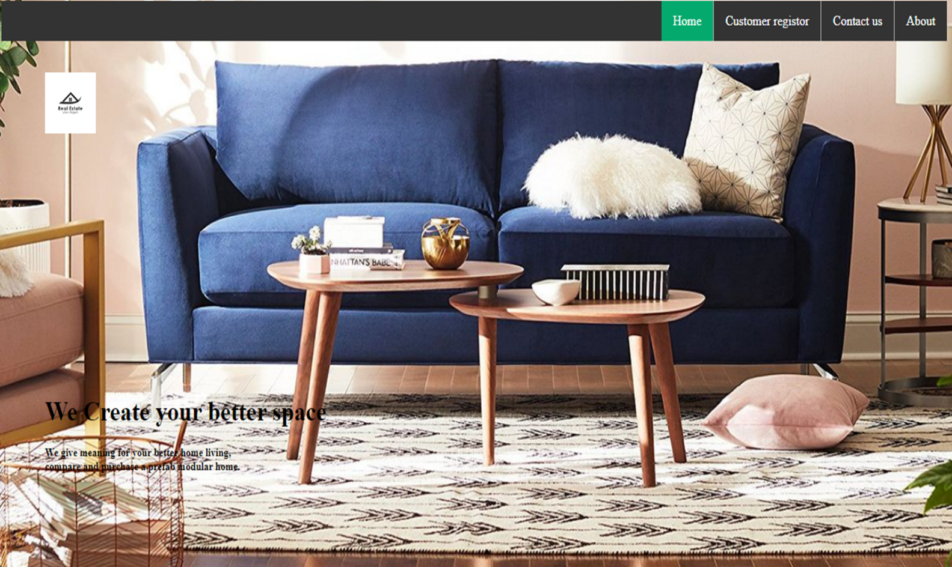

# Fig 8.1 HOME PAGE USING TEMPLATE

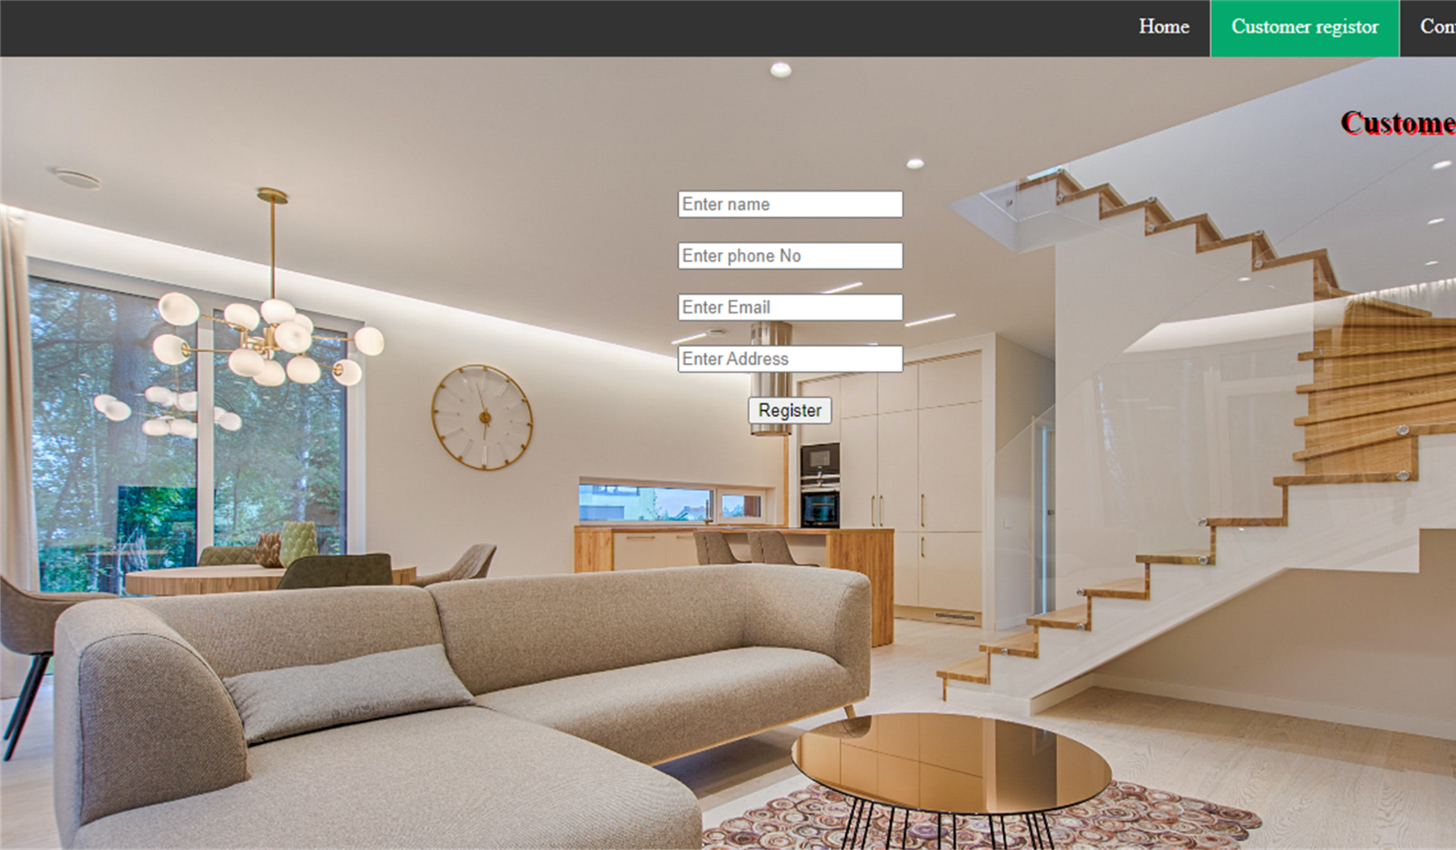

## Fig 8.2 CUSTOMER REGISTER TEMPLATE



**Fig 8.3 CONTACT US TEMPLATE**

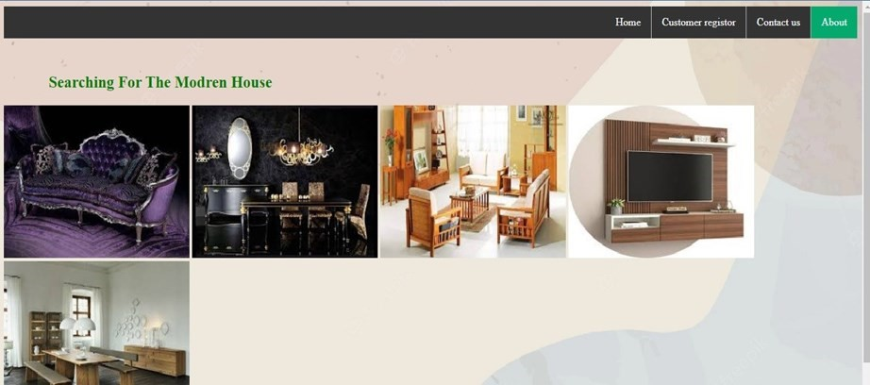

Crafted with excellent material

Modern Interior Design Modern Kitchen Interior Design Room Interior Design Modern bathroom Interior Design

## Fig 8.4 SEARCHING VARITY OF FURNITURE



**Fig 8.5 WEB PAGE USING FIGMA**

**CONCLUSION**

Using a template for online furniture store offers numerous advantages. Firstly, it saves valuable

Time and effort by providing a pre-designed framework that can be easily customized to match your

Brand. Secondly, templates offers a user-friendly design and seamless shopping experience for

Customers, enhancing their satisfaction. Additionally , integration of secure payment options

Ensures a smooth checkout process , instilling trust in your customers. The consistency in design

And layout achieved through templates also helps establish a strong brand image. Moreover,

Templates often come with built-in e-commerce features , streamlining business operations

And improving the overall user experience. Overall, utilizing a templates for your online Furniture store is a practical and efficient choice.

**REFERENCE**

* https://youtu.be/V_cioLTaDvQ
* https://youtu.be/CQZxeoQeo5c
* https://www.wpbeginner.com/beginners-guide/how-to-create-an-email-newsletter/ <https://youtu.be/xLg3RQ_gD0s>
* <https://www.w3schools.com/>
* https://youtu.be/Y9XE1zhQl4M